APPLECROSS SENIOR HIGH SCHOOL
3AB Human Biological Science
Test 3

Choose the best answer from the options provided. Indicate your answer on the multiple choice answer sheet.

DO NOT WRITE ON THIS TEST PAPER

1. Which of the statements about electrophoresis is false?
A. The process requires an electric current
B. This technique can be used to separate charged molecules
C. Large molecules migrate more slowly in the agarose gel than small molecules
D. None of them.

2. What are restriction enzymes?
A. enzymes that are limited (i.e., restricted) in how big they can become
B. enzymes that cut through a DNA helix wherever they encounter a specific sequence of nucleotides
C. a type of plasmid
D. a short tandem repeating sequence in DNA

3. In recombinant DNA technology, plasmids may be used to:
A. introduce foreign DNA into human cells
B. cut DNA at a specific location
C. activate restriction enzymes
D. introduce foreign DNA into bacteria

Questions 4 and 5 refer to the diagram below

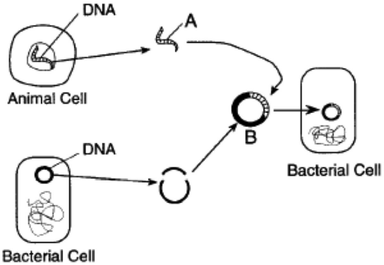

4. Structure A contains a
A. gene
B. messenger RNA molecule
C. single nucleotide only
D. plasmid
5. Structure B represents
A. a ribosome
B. recombinant DNA
C. transfer RNA
D. a vector

6. Which of the following tools of recombinant DNA technology is INCORRECTLY paired with one of its uses?
A. restriction enzymes - production of DNA fragments for gene cloning.
B. DNA ligase - enzyme that cuts DNA, creating sticky ends.
C. DNA polymerase - copies DNA sequences in the polymerase chain reaction.
D. vector - often a bacteriophage to host a plasmid

7. What is the "polymerase chain reaction" (PCR) technique?
A. An elegant chemical technique that utilizes the body’s own DNA polymerase to synthesize DNA that is complementary to the parent DNA fragments
B. A technique that allows investigators to determine the nucleotide sequence of a given gene
C. A technique that has led to the development of genetic screening tests of newborns for genetic disease (e.g., cystic fibrosis) once the nucleotide sequence of disease-causing gene is known
D. A technique that incorporates repeated cycles of heating and cooling of DNA segments in the presence of primers and heat-resistant DNA polymerase

8. What are the temperatures (degrees Celsius) that represent the following steps in PCR?

Annealing, Denaturation, Extension

A. 55, 95, 32
B. 40, 30, 90
C. 55, 95, 72
D. 72, 95, 32

9. What is the main difference between embryonic and adult stem cells?
A. Embryonic stems cells are undifferentiated; adult stem cells are partially differentiated.
B. It is easier to induce dedifferentiation in adult stem cells.
C. Embryonic stem cells are easier to isolate than are adult stem cells.
D. Both A and C

10. Which of the following would you expect to be a drawback to PCR techniques?
A. PCR has the potential to create positive results from very low levels of contamination.
B. PCR can be used with very small samples such as single sperm cells.
C. PCR is very rapid; in some cases results can be available in a few hours
D. All of these

11. What benefit does administration of genetically engineered human insulin provide to patients that pig/bovine insulin does not?
A. There was no benefit; the nucleotide sequence that determines the structure of insulin is the same in all three species.
B. Allergic reactions were avoided by using the recombinant human insulin.
C. It could be produced in large quantities using bacteria/yeast genetically engineered to carry the human insulin gene.
D. B and C

12. Some of the steps involved in Gene Cloning are given below:
i) Insertion of isolated gene to the vector
ii) Introduction of recombinant vector to the host
iii) Isolation of desired gene
iv) Expression of recombinant gene in host
v) Extraction of recombinant gene product

Which of the following shows these steps in correct order?

A. iii, i, iv, ii, v
B. iii, i, ii, iv, v
C. i, ii, iii, iv, v
D. ii, i, iii, iv, v

13. What key feature of Taq polymerase allows PCR to be conveniently performed?
A. Taq polymerase does not require primers
B. Taq polymerase does not require a template.
C. Taq polymerase is not damaged by heating
D. Taq polymerase can work at very low temperatures

14. Restriction enzymes attach at specific sequences on DNA called
A. Cleavers
B. Exons
C. Recognition sites
D. Major satellites

15. In attempting to determine the identity of a criminal, the only evidence is a tiny drop of blood. How can this drop of blood be used to identify the specific individual?
A. Use the sample to determine the individual’s ABO blood group.
B. Use PCR to increase the amount of DNA available
C. Use gel electrophoresis to determine the length of the DNA found in the sample.
D. Both B and C

16. Recombinant DNA techniques
A. utilise restriction enzymes that help to join segments of DNA back together.
B. rely on DNA ligase that cuts DNA to form sticky ends.
C. have been used to produce insulin, growth hormone and the flu vaccine
D. often use bacteria as they only have one long strand of DNA to manipulate.

17. The diagram below shows the results of electrophoresis of probes for the site which has been shown to be altered in Huntington's disease. The male parent, (as shown in column 2) developed Huntington's disease when he was 40 years old. He has 9 children, 6 of which (3,5,7,8,10,11) have Huntington's disease. The age at which the symptoms first began is shown by the number above the band of the PCR fragment.

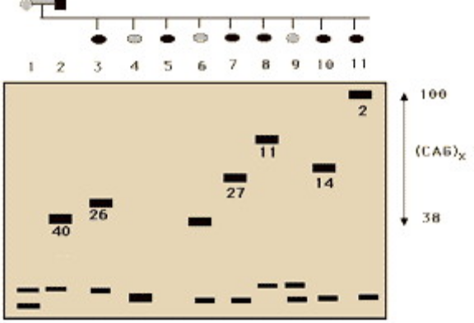

What is the prognosis for the normal children 4, 6, and 9?
A. 4 and 9 do not have the trait, and will not get Huntington's disease, but 6 is likely to start the disease when he reaches his father's age of 40.
B. 4, 6, and 9 are lucky and have not inherited the defect causing Huntington's disease.
C. 4, 6, and 9 will still develop Huntington's disease at some point in their lives, since the disease is inherited as a dominant trait.
D. Two of the three will develop the disease, since it is inherited as a dominant trait, but the data does not allow you to predict which two.

18. Imagine you are looking at a DNA fingerprint that shows the pattern of a mother's DNA and her child's DNA. Will all of the bands on the electrophoresis gel showing the child's DNA match those of the mother?
A. No, because a person’s DNA pattern changes with age.
B. Yes, because the DNA of mothers and children are identical.
C. Yes, because the child developed from an egg produced by the mother.
D. No, because the father contributed half of the child's DNA

19. To treat cystic fibrosis (CF) through gene therapy, a healthy gene that codes for the proper amino acid sequence is placed into the cells of the patient’s lung tissue. Which statement applies to this technology?
A. Airborne bacteria with the healthy gene are injected into lung cells.
B. CF patients are infected with a virus are inhaled.
C. Healthy genes are inhaled as free DNA fragments in an air sample.
D. Healthy genes are injected into lung cells through microsurgery

20. Electrophoresis separates DNA fragments of different sizes, with ____ fragments moving closer to the ____ pole.
A. shorter, negative
B. shorter, positive
C. longer, negative
D. longer, positive

21. The diagram shows some stages in making recombinant DNA using E. coli plasmids. Which are the correct enzymes X and Y and order of bases at 1, 2 and 3?
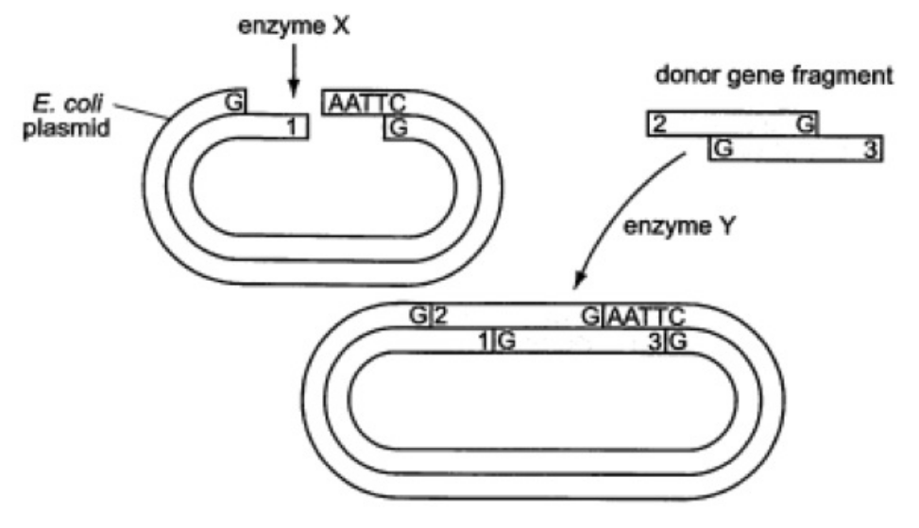
X Y 1 2 3
A. ligase restriction TTAA AATT TTAA
B. restriction ligase TTAA AATT TTAA
C. ligase restriction AATT TTAA AATT
D. restriction ligase AATT TTAA AATT

22. The immediate goal of the Human Genome Project was to
A. develop new technologies for studying DNA
B. compare the genomes of a large number of individuals from different parts of the world
C. map all the human genes and determine the nucleotide sequence of the entire human genome
D. find cures for human genetic disorders

23. Which of the following is NOT a step taken to produce recombinant DNA using human DNA?
A. use of yeasts to circularize DNA
B. seal human DNA fragments into plasmids with DNA ligase
C. cut both human and plasmid DNA with the same restriction enzymes
D. isolate and purify DNA from tissues and from plasmids

24. DNA fingerprints used as evidence in a murder trial look something like supermarket bar codes. The pattern of bars in a DNA fingerprint shows the
A order of genes along particular chromosomes
B presence of various-sized fragments of DNA
C exact location of a specific gene in a genomic library
D presence of dominant or recessive genes

25. Which of the following does NOT occur during PCR?
A. Attachment of primers.
B. Repeating cycles of heating and cooling DNA.
C. The amount of DNA doubles with each round of replication.
D. The strands of the original DNA sample are unwound.

26. Which of the following is not a purpose of genetic modification?
A. To create proteins used in vaccines (e.g. hepatitis B vaccine).
B. To modify the characteristics of an organism.
C. To create hormones such as insulin or human growth hormone.
D. To create antibiotics

27. In recombinant DNA experiments, ______ is used to cut pieces of DNA and ______ joins the resulting fragments to form recombinant DNA.
A. a restriction enzyme . . . DNA ligase
B. DNA ligase . . . a restriction enzyme
C. a plasmid . . . DNA ligase
D. a transposon . . . a restriction enzyme

28. Gene therapy can be made highly effective by conducting
A. gene therapy using tissues from a donor.
B. gene therapy through injecting modified cells from the same individual
C. fingerprinting
D. transplantation of cells from a family member

29. During DNA replication the enzyme that joins the small fragments of the lagging strand together into a continuous strand is called _______.
A. DNA gyrase
B. DNA ligase
C. DNA polymerase
D. Primase

30. A “transgenic organism” is an organism containing inserted
A. chromosomes.
B. proteins.
C. enzymes.
D. genes.

